REGISTRATION
Please print and send these forms with payment to:
CMMC Student Programs P.O. Box 421 N. Chatham, MA 02650

Student Name: ________________________________ Grade Entering: _______
Program Title: _________________________________________
Program Dates: _____________________ Circle Time of Day: Mornings / Afternoons
Parent/Guardian Name: ____________________________________________________
Email: ______________________________________ Best Phone: _________________
Mailing Address: _________________________________________________________
COST: ___________________ TOTAL (If registering for multiple courses): _________
□ Check # _________ enclosed (payable to CMMC)
□ Please charge my credit card
❑ Visa ❑ Mastercard
Card Number: ________________________________________
Expiration Date:__________/__________
Security Code: ______________
Signature: ___________________________________________
POLICIES: Classes may be canceled due to low enrollment and fees will be refunded. Class withdrawal is non-refundable unless a one week notice is provided by email before the date of the workshop. A $30 processing fee is applied to cancellations. CMMC is not set up for one-to-one or assistive instruction and parents will not be able to monitor needs. Please choose classes that will be a good fit for your child’s personality and interests as there is no refund of student fees if a student is dismissed for inability to following the Code of Conduct. Emergency medical permit, publicity release, and code of conduct must be signed at registration. CMMC will not be held responsible for injuries sustained during a CMMC class and parents/guardians are responsible for replacement costs or damage repair to CMMC property if incurred.
Thank you, and we look forward to an amazing STEM experience with your student (s)!!

EMERGENCY MEDICAL PERMIT: PARENT/GUARDIAN PERMISSION FOR
CHATHAM MARCONI MARITIME CENTER (CMMC) STUDENT PROGRAMS

*All forms must be completed prior to participation in our programs.

Child’s name_________________________________ Grade : ____ DOB ____________

Parent/Caregiver e-mail_______________________________________________

Address_____________________________________________________________

Best Phone Number and Daytime Contact Name ___________________________

Emergency Number and Contact Name___________________________________

Parent/Guardian names(s)_____________________________________________

Parent/Guardian cell/work phone ______________________________________

Name of Child’s Physician:_____________________________________________

Insurance Company/Policy #: ___________________________________________

To ensure your child has the most positive experience in class, please identify any educational, physical, behavioral, emotional, or medical needs that may affect your child’s full participation. Any information you provide will remain confidential and will be used to plan for positive class experiences.” If you prefer, please email or call Vicki Hill, the program director at cmmc.education.director@gmail.com or 508-945-8889. ________________________________________________________________________________________________________________________________________________________________________________________________________________________________________________________________________________________________________________________________________________________

List all medications, dosage, and diagnosis: _______________________________________________
List any/all allergies of participating child: _________________________________________________
Please identify any acute or chronic medical conditions: _____________________________________

PARENTAL/GUARDIAN CONSENT FORM/RESPONSIBILITY CLAUSE
In the case of emergency while participating in this event, I hereby give my consent for a qualified physician to perform any medical or surgical procedures he/she deems necessary to the welfare of the child listed above. It is understood that every attempt will be made to contact parents, guardians, and relatives listed prior to taking such actions. The undersigned does hereby assumes and agrees to pay in full any indebtedness of any physician or surgeon fees as well as hospital charges for such service.

_______________________________ / ___________________________ / __________________
(Signature of Parent or Guardian) (Printed Name of Parent or Guardian) (Date)

 Publicity Release

Chatham Marconi Maritime Center
P. O. Box 421
North Chatham, MA 02650

Student's name: ________________________________________________________________________
PERMISSION TO BE PHOTOGRAPHED
I give the Chatham Marconi Maritime Center, Inc., its agents and its corporate sponsors the right to interview and/or take photographs, audio-visual recordings of my child to be used in promotional, educational or fundraising materials including, but not limited to videos, pamphlets, and brochures. I understand that my child’s name may be used in connection with these materials. This release is voluntary, and I give it in the interest of public information, education, the furtherance of the goals of this institution, or other lawful purposes. I acknowledge that I have legal authority to sign this form on behalf of the name mentioned above.

Parent/Guardian’s Signature ___________________________________
Date ____________________________

Marconi Chatham Maritime Center
P. O. caja 421
North Chatham, MA 02650

Nombre del estudiante: ________________________________________________________________________
PERMISO para ser fotografiado
Doy la Chatham Maritime Marconi Center, Inc., sus agentes y sus patrocinadores corporativos y el derecho a la entrevistas y / o tomar fotografías, grabaciones audiovisuales de mi hijo para ser utilizados en promoción, educativos o materiales de recaudación de fondos, incluyendo, pero no limitado a los vídeos, panfletos y folletos. Entiendo que mi hijo nombre puede ser utilizado en conexión con estos materiales. Este comunicado es voluntaria, y se la entregará en el interés de público la información, la educación, la promoción de los objetivos de esta institución, u otros propósitos lícitos. Reconozco que Tengo autoridad legal para firmar este formulario en nombre del nombre mencionado anteriormente.

Padre / Guardián s Firma ___________________________________
Fecha ____________________________

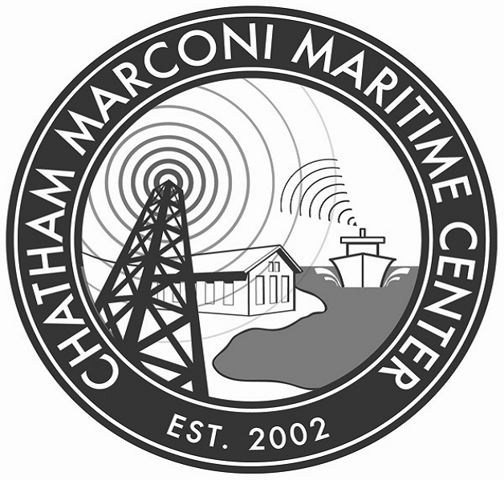 CODE OF CONDUCT and POLICIES

Required to be filled out by each student and signed by parent
1. Participation ☺
- Please be prompt and ready to participate in the exciting activities that are planned!
- Be a positive team member for your group.

2. Respect ☺
- Respectful and positive language is expected.
- Respect for the facilities and property is expected.
- Respect for the instructor is expected.

3. Safety ☺
- Instructors are not authorized to administer medications.
- Please follow all safety instructions

CMMC instructors have extensive experience in the classroom and do a great job coaching students to apply positive behaviors to situations in the classroom. Still, we reserve the right to dismiss a student, without refund, if misbehavior affects the experience of other students.

*******************************************************************************************

I, (please print) ________________________, have read and understand the Code of Conduct and agree to abide by class rules.

Youth Signature ___________________________ Date: _________________________

POLICIES: Classes may be canceled due to low enrollment and fees will be refunded. Class withdrawal is non-refundable unless a one week notice is provided by email before the date of the workshop. A $30 processing fee is applied to cancellations. CMMC is not set up for one-to-one or assistive instruction and parents will not be able to monitor needs. Please choose classes that will be a good fit for your child’s personality and interests as there is no refund of student fees if a student is dismissed for inability to following the Code of Conduct. Emergency medical permit, publicity release, and code of conduct must be signed at registration. CMMC will not be held responsible for injuries sustained during a CMMC class and parents/guardians are responsible for replacement costs or damage repair to CMMC property if incurred.

Thank you, and we look forward to an amazing STEM experience with your student (s)!!

I, (please print) ________________________, parent/guardian of the above named youth have read and have assisted my child in understanding the above Code of Conduct and Policies.

Parent/Guardian Signature ___________________ Date: _________________________

